Communion Set Up Procedure

- Supplies:
- Communion supplies are in the Sanctuary to the right of the Table.
    - The cabinet marked Spirit Alive is where our supplies are as well as the open refrigerated supplies being in the small refrigerator in the back of the room to the right.
- Take down the communion plate, two chalices and one small wine goblet from the shelves in the cabinet.
- Get the communion bread from the freezer in the small refrigerator and place it in the communion plate.
- Get the two small bowls in the refrigerator filled with pre-filled communion.
- Fill the two chalices just above half full of the alcohol-free wine. The open wine will be in the refrigerator: if there is none open, there are unopen bottles in the bottom right-hand shelf.
- The wine can sit out on the counter until after service as the left-over wine in the small wine goblet will go back into the bottle after worship.
- There are two baskets in the cabinet that will get filled with the Spirit Alive Glasses.
- Two empty Dishwasher baskets will get placed out in the sanctuary as well: you will need paper towels to go underneath them.
- Fill the baskets with the wine glasses to the best of your ability.

- Table preparation: (if either one of the two white tablecloths with white crosses on it are dirty, there are clean ones in the box on the top shelf of the cabinet, in cloth in the box are usable)
- There are three tablecloths. One large cloth is placed in the center of the table at an angle.
- Place the two chalices on the tablecloth, to the right, and cover them with one of the clothes with a white cross on it.
- Place the communion plate in the center on the tablecloth and cover it with the second cloth with a white cross on it.
- Place hand sanitizer to the right of the Communion setup on the table.
- Two paper towels folded into small squares get placed next to the wine chalices.
- Three wine glasses also get placed on the table so that the pastor and the communion assistants have the for when they do communion.
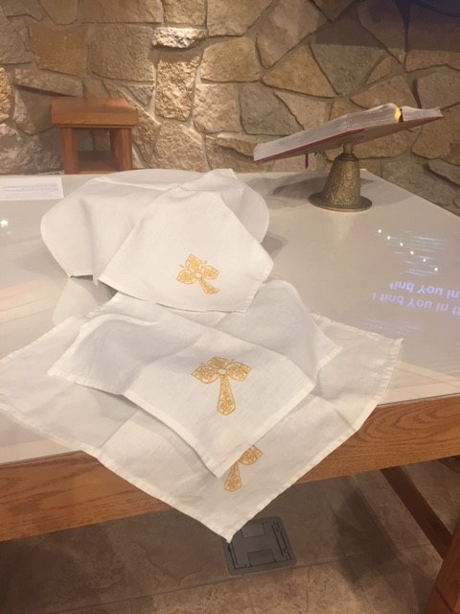

- There are four TV Tray tables in a stand.
- Two with the W’s goes to each side of the sanctuary.
- The two without the W’s (they wobble a bit) go in front of the table.
- Place the dishwasher racks on each W Table with paper towels underneath them.
- The two baskets with clean wine glasses and the pre-filled communion cups go onto the two tables in the middle in front of the table.

- Clean up after service:
- When the church service is over, go to the table and remove the communion plate and chalices.
- Dispose of the wine in the chalices by pouring it outside on the ground. (Never pour the wine down the drain, as it has been consecrated and should be treated this way. Pouring it outside returns it to nature. This needs to be done away from any entrances into the building)
- If the left-over communion bread is only broken in half – it can go back into the package in the freezer. The other pieces of left over communion bread need to be broken into smaller pieces and thrown outside. (away from any exits into the building)
- The left-over clean wine glasses in the baskets can go back into the cabinet.
- Small two bowls can go back into the refrigerator.
- Wash and dry chalices and place them back in the cabinet.
- Wash and dry the plate and wine jug and place them back in the cabinet.
- If the tablecloths have wine spots, please let the pastor know.
- The two dish racks with dirty wine glasses need to be washed. These can be run through the dishwasher (see instructions posted.)
- Once the glasses are washed, please place paper towels on top of the refrigerator and place the dish racks with the clean glasses on top of the paper towels.
  - Please place the left-over cleaned glasses in the third rack on top of the two wet ones.

